### **Enhanced Use Cases for Customers**

1. Customize Orders
   * Normal: A customer logs in, selects a burger, and customizes it by removing onions and adding avocado.
   * Exceptional: The customer wants to remove an ingredient not listed separately (like a spice blend in a sauce) which the restaurant cannot accommodate without altering the dish for all customers.
2. Repeat Last Order
   * Normal: A regular customer chooses to reorder their favorite meal from last week with just a few clicks.
   * Exceptional: The system fails to retrieve a past order due to a technical issue, or the restaurant has discontinued an item from that order.
3. Schedule Orders
   * Normal: A customer schedules a birthday dinner delivery for 7 PM on a specific date.
   * Exceptional: The customer tries to schedule a delivery for a time when the restaurant is unexpectedly closed or fully booked.
4. Participate in Loyalty Programs
   * Normal: A customer earns points after each purchase and redeems them for a free appetizer on their next order.
   * Exceptional: Points fail to accrue due to a system glitch, or the customer attempts to redeem points during a blackout period when redemptions are not allowed.
5. Provide Feedback
   * Normal: After dining, a customer submits a positive review and rating through the platform.
   * Exceptional: A customer tries to submit feedback but encounters a system error that prevents the review from being saved or posted.

### **New Use Cases for Stores**

1. Update Menu Items
   * Normal: A chef updates the menu to include a new seasonal dish.
   * Exceptional: A menu item update is not reflected in real time due to synchronization delays, leading to customer confusion.
2. Handle Special Requests
   * Normal: A chef receives a request to make a dish gluten-free and successfully adjusts the recipe.
   * Exceptional: A special request is lost or not communicated to the kitchen, resulting in a customer receiving the wrong dish.
3. Manage Inventory
   * Normal: Inventory data helps a manager order the right amount of fresh produce for the week.
   * Exceptional: The inventory system shows incorrect data due to input errors, causing overordering or shortages.
4. Analyze Sales Data
   * Normal: Managers use sales analytics to identify that a particular dish is very popular on weekends and adjust staffing and stock accordingly.
   * Exceptional: Sales data is skewed by a promotional event, leading to incorrect conclusions about regular customer preferences.
5. Promote Specials
   * Normal: A restaurant promotes a discount on all pasta dishes through the platform, driving increased orders.
   * Exceptional: A promotion is not deactivated after the intended end date due to a system error, leading to unintended discounts.

### **Expanded Use Cases for Surfers**

1. Create Account
   * Normal: A surfer easily creates a customer account using their email address.
   * Exceptional: A surfer encounters a bug during the sign-up process, such as a captcha error, which prevents account creation.
2. Subscribe to Updates
   * Normal: A surfer subscribes to updates from their favorite restaurant and receives emails about upcoming specials.
   * Exceptional: Email updates go to the spam folder, or the surfer receives too many emails, leading to unsubscribing.
3. Interactive Menu Exploration
   * Normal: A surfer filters the menu to show only vegan options and sorts by popularity.
   * Exceptional: Filtering errors occur, showing incorrect items that do not meet the dietary preferences specified.

### **Enhanced Use Cases for Customers**

### **Customize Orders**

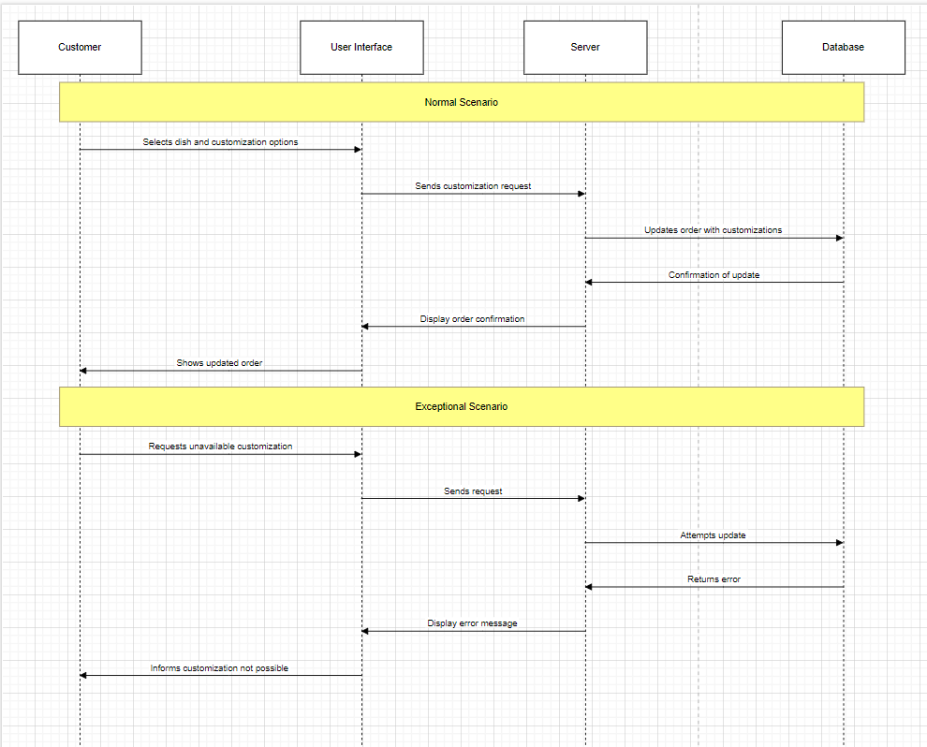

### **Repeat Last Order**

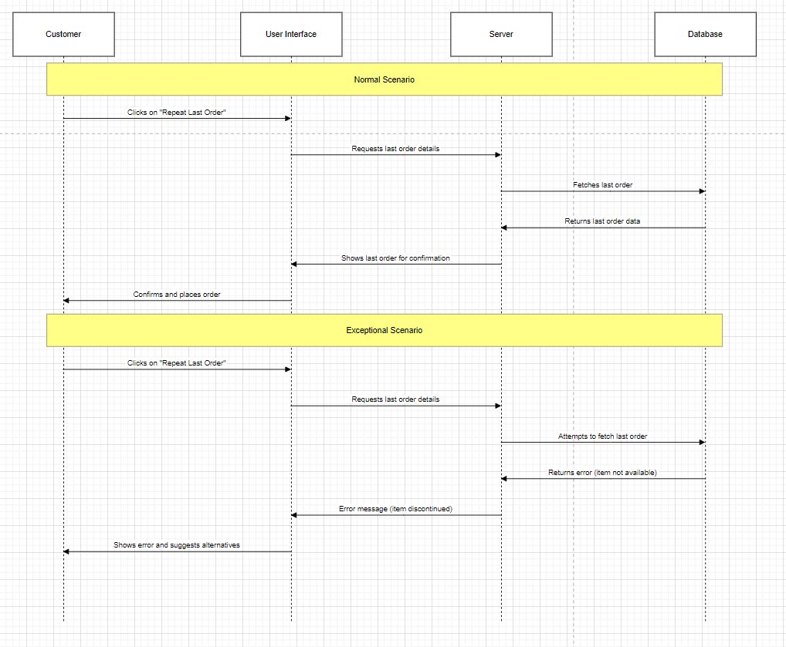

### **3. Schedule Orders**

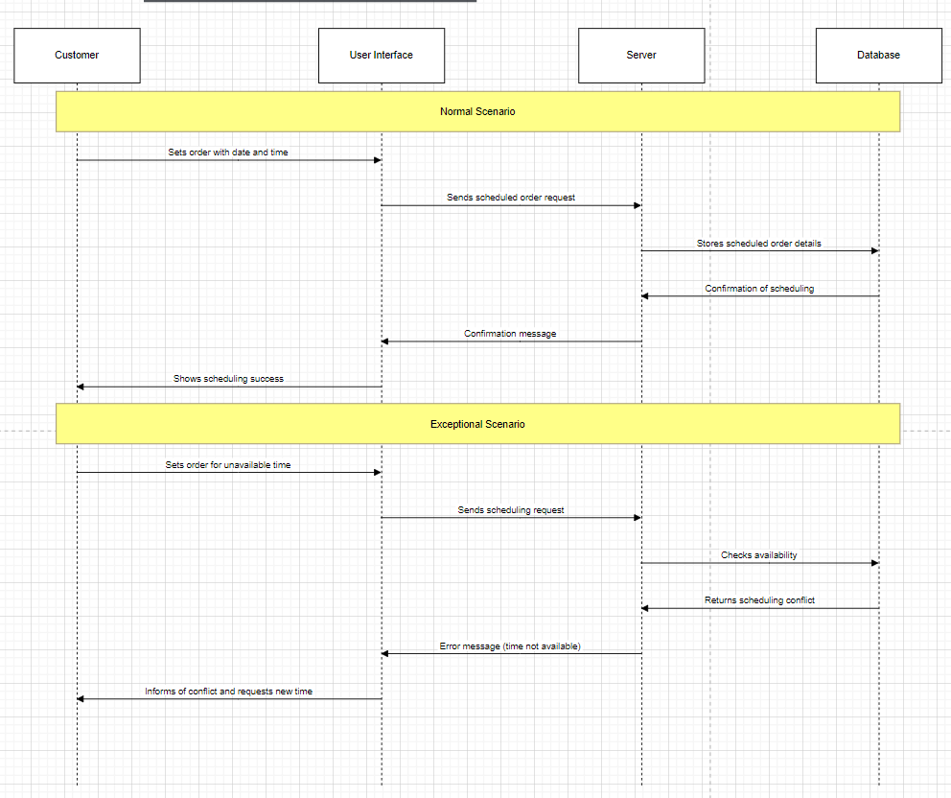

### **4. Participate in Loyalty Programs**

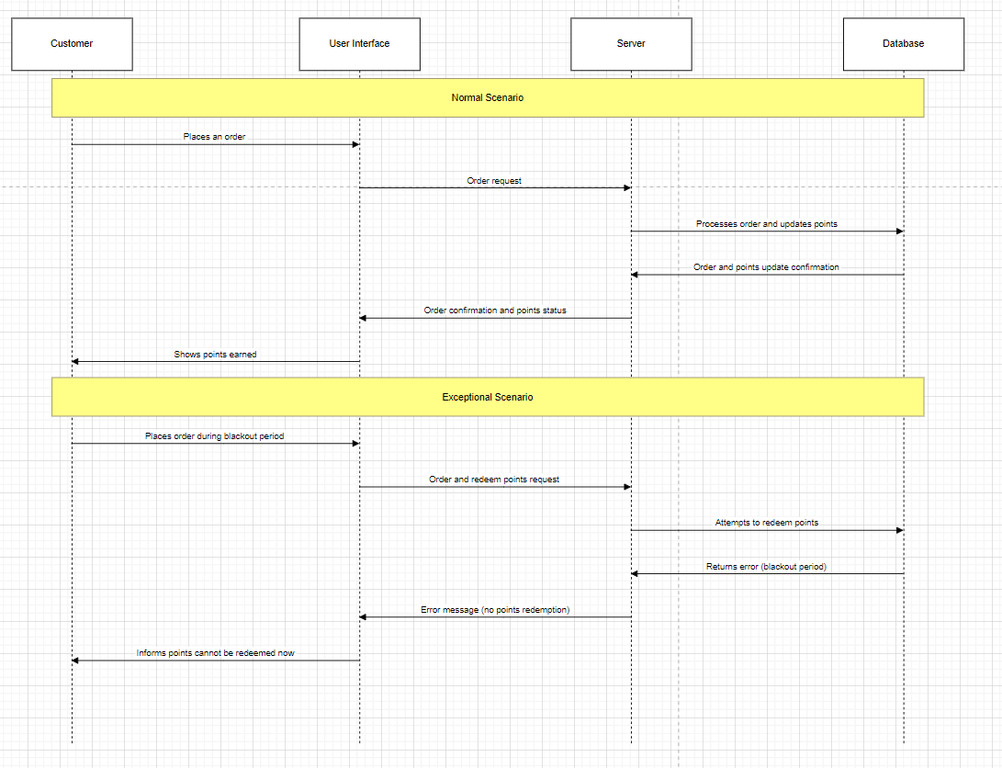

### **5. Provide Feedback**

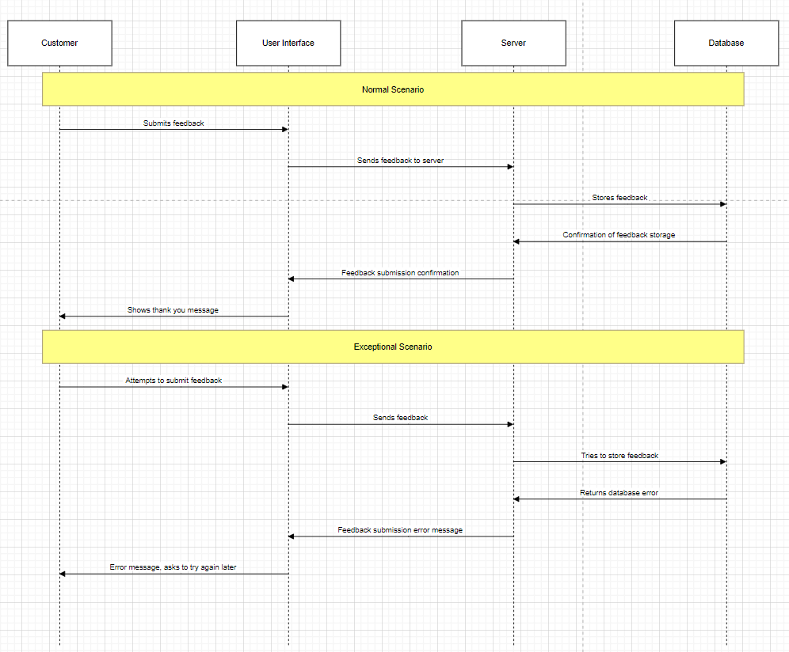

### 

### **New Use Cases for Stores**

### **1. Update Menu Items**

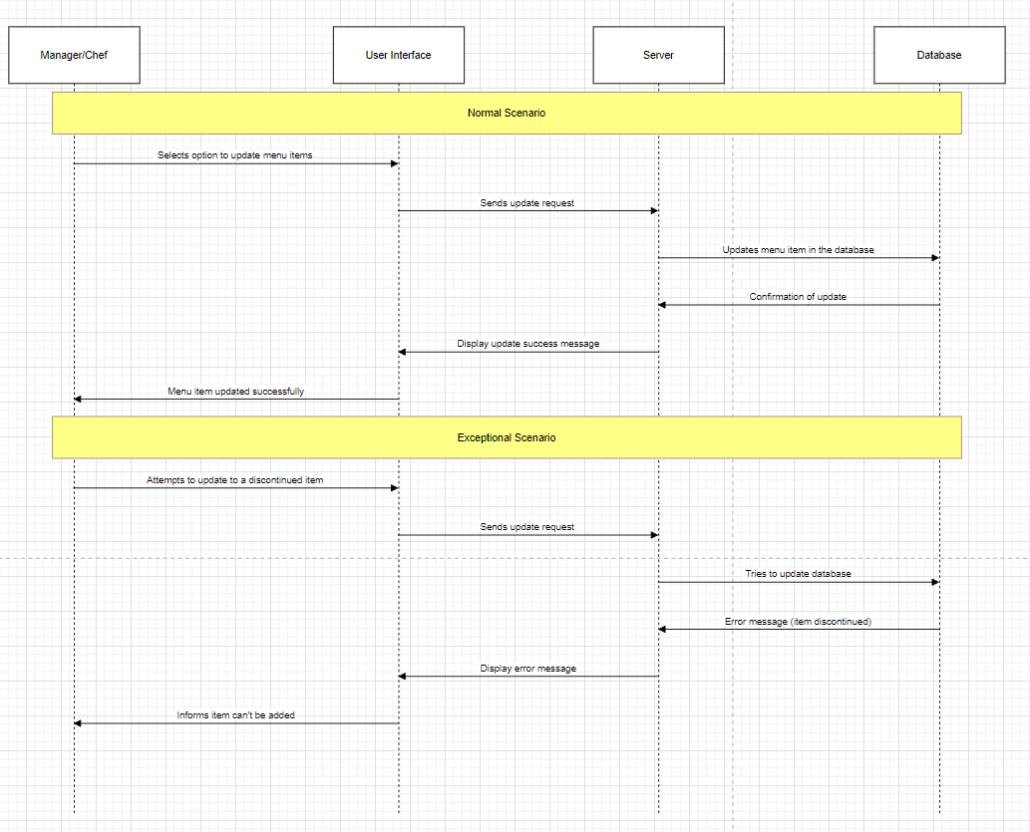

### 

### **2. Handle Special Requests**

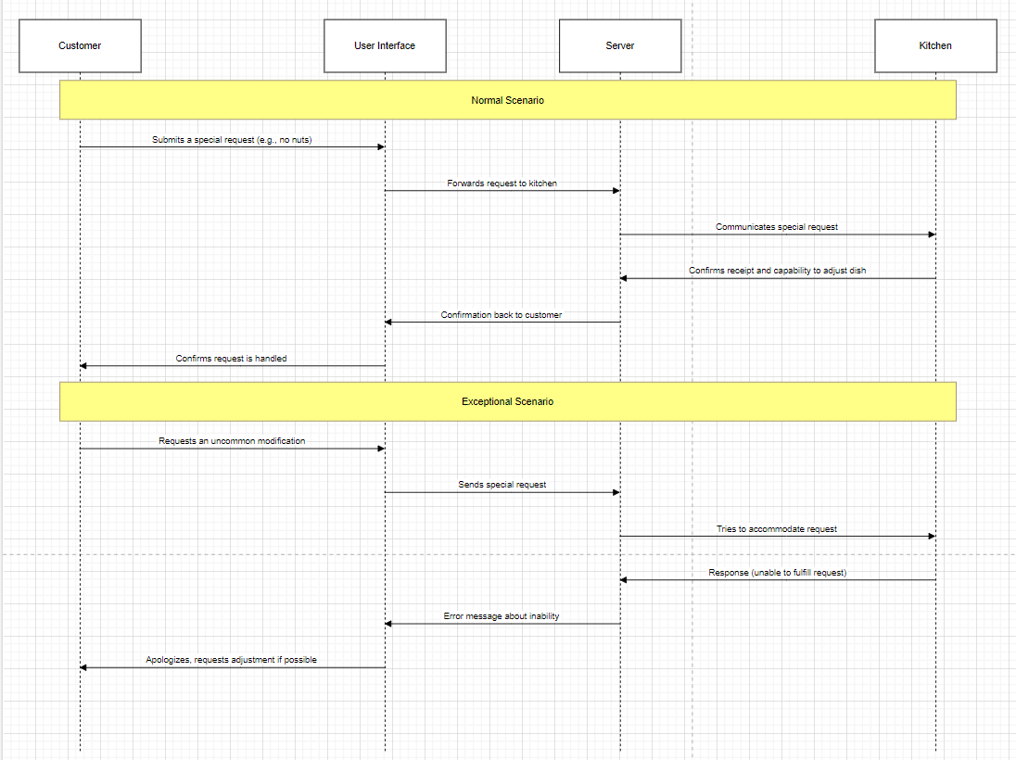

**3. Manage Inventory**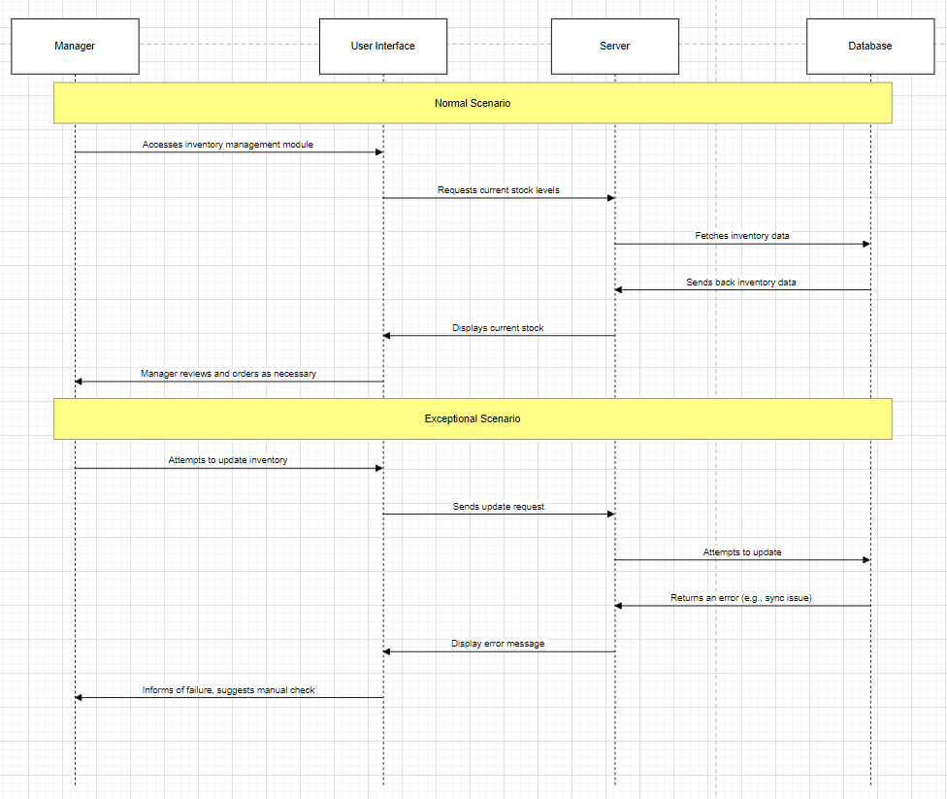

### **4. Analyze Sales Data**

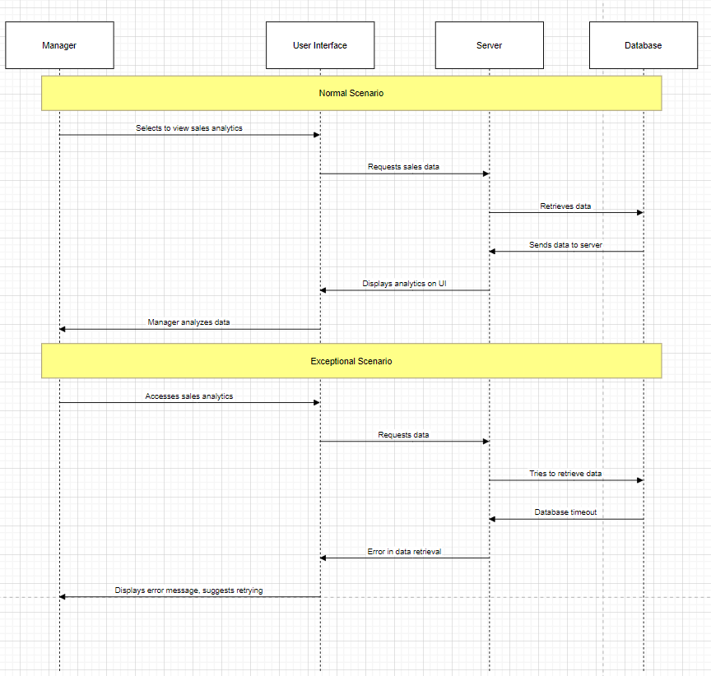

### **5. Promote Specials**

### **Expanded Use Cases for Surfers**

### **1. Create Account**

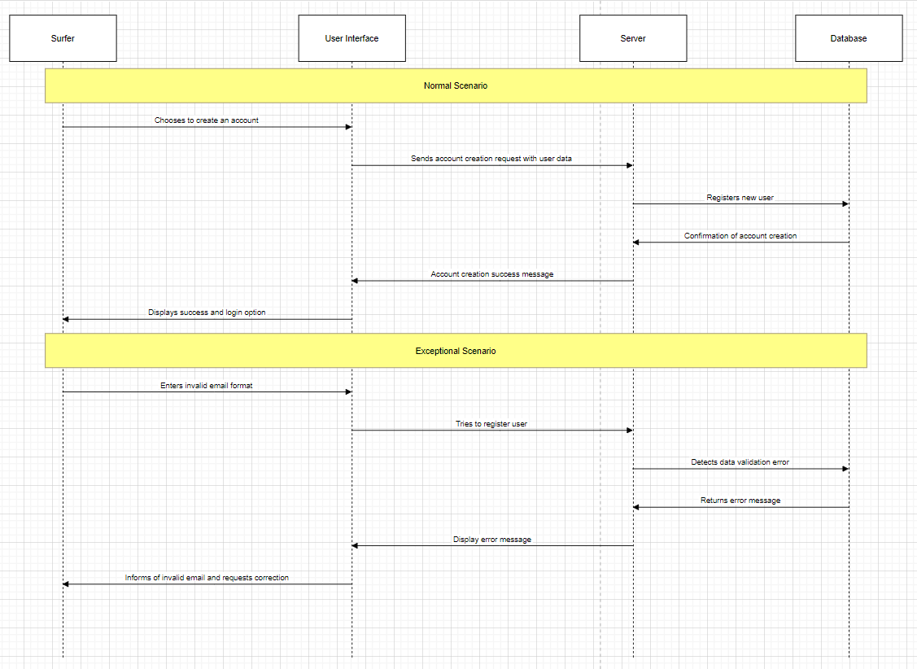

**2. Subscribe to Updates**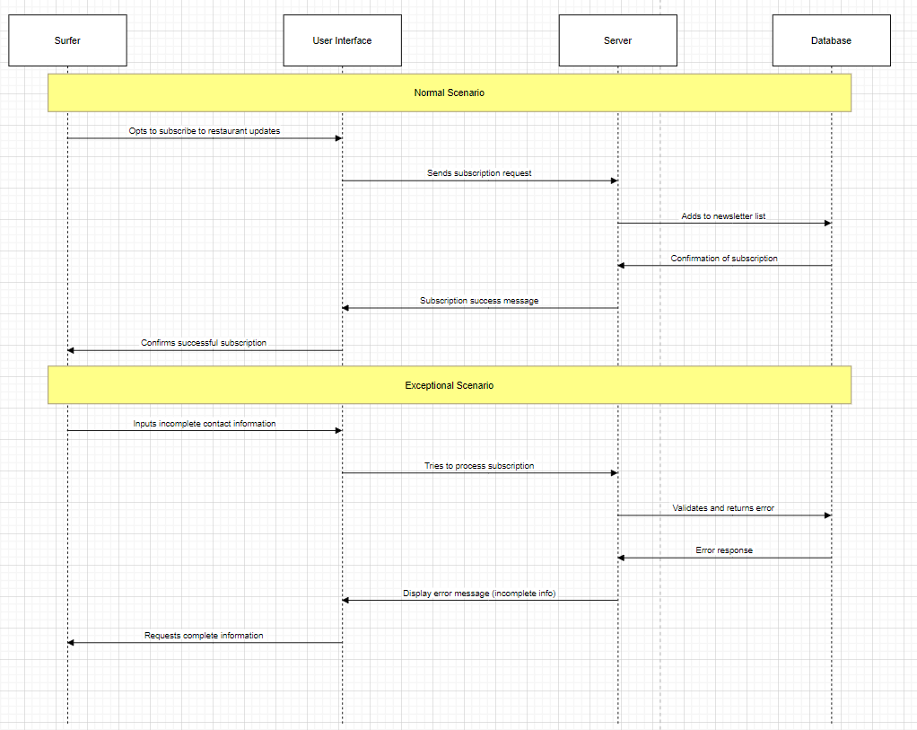

### **3. Interactive Menu Exploration**

